Title of the Unit:  Creating Texture using Recycled Materials | Teacher’s Name: Miss. George
Grade Level: 2nd | Time required: 8 days

Standards Addressed:  Visual Art Standards and potential connections to other subject areas | Visual Arts:  2.1 The student will generate a variety of solutions to art-making  problems.  2.2 The student will incorporate unanticipated results of art making into works of art.  2.3 The student will depict imaginary experiences in works of art.  2.4 The student will create works of art inspired by a variety of concepts, themes, and literary sources.  2.6 The student will use foreground and background in works of art.  2.7 The student will depict objects according to size and proportion within works of art.  Science:  2.5 The student will investigate and understand that living things are part of a system. Key ideas include  a) plants and animals are interdependent with their living and nonliving surroundings;  b) an animal’s habitat provides all of its basic needs; and  c) habitats change over time due to many influences.
Enduring Understandings: | What is texture?  How can you use paint and reusable materials to show texture?
Essential Questions: | How can the designs and patterns created be used to tell a story or represent something else?  What can we do to reduce amount of waste?
Student Learning Objectives: | The student will be able to... create a(n) animal or plant of their choosing and an environment for it to live in on paper using paint and recycled materials
Unit Vocabulary:  (List unit-specific words and phrases students need to understand, including  artistic concepts, techniques, genres, and forms; key figures; historical periods, etc.) | Layers  Texture  Adapt  Composition  Foreground  Background  collage
Essential Materials: | Paper recycled materials  Paint *gelli plate or similar surface  Markers scissors  Pencils and pens glue
Utilized Resources:  (List texts, websites, primary sources, videos, recordings, artworks, etc. to be used in the unit.) | Animals, Animals audio book on Youtube  Examples of Eric Carle’s work – Eric Carle Museum website  Personal and student examples
Unit Assessment:  (Describe assessments to be used in the unit, connecting directly to Student Learning Objectives and Standards Addressed). Include any rubrics. | Diagnostic (beginning): Understanding vocabulary
 | Formative (in-process): Applying vocabulary and examples to create their own prints
 | Summative (end): application to the real world: Reduce, reuse, recycle
Differentiation:  (Indicate how students will receive differentiated tasks, supports, and assessment.). | - Tiered instruction  - Varied products  - Personal agendas
Accommodations:  (Describe how tasks and activities will be modified to provide equitable access to learning.) | Provide extra assistance as needed  Provide enough samples and duplicates of samples so that students can hold their own
Lesson Plan Overview: Title of each lesson  Duration  Please place in order expected sequence. | 1. Texture
 | 2. Texture and Mixed Media
 | 3. Layers
 | 4. Layers

Lesson 1
Teacher: George | Date(s): March 19-21
Grade Level or Course: 2nd | Content or Unit: Texture and Mixed media

STAGE 1: Desired Results ~ What will students be learning?
SOL/Learning Objective  Specify the behaviors, conditions, and criteria. Indicate the verbs used in the Curriculum Framework.  6 Create  5 Evaluate  4 Analyze  3 Apply  2 Understand  1 Remember | 2.1 The student will generate a variety of solutions to art-making  problems.  2.2 The student will incorporate unanticipated results of art making  into works of art.  2.4 The student will create works of art inspired by a variety of concepts, themes, and literary sources.
Essential Questions & Understandings/Big Ideas  Look for Essential Questions that are overarching or topical and help guide the unit plan. These questions promote conceptual thinking and add coherence to a series of lessons. An idea is “big” if it helps make sense of seemingly isolated facts. | What is Texture?  What are some examples?  What are some ways we can show different texture?  What elements effect texture?
Key Vocabulary  Look for in the Curriculum Framework and other adopted resources. | Texture  Pattern  Collage  Layer
STAGE 2: Assessment Evidence ~ What is evidence of mastery?
Assessment Part 1  Start with the end in mind! Consider here a sample question or performance task students will need to do as evidence of mastery of this objective. | Formative, discussion on texture  -vocabulary  -where do you see textures? animals? plants? everyday objects?  -how can layers create texture?  Show examples of prints that I have made and have students guess what material i used to create the texture.
Possible misconceptions or learning gaps  Complete the above task yourself; think about what might be hardest for students to grasp? | Texture doesn’t have to be three-dimensional. It can be achieved through layers and patterns
STAGE 3: Learning Plan ~ What are the strategies and activities you plan to use?
Snapshot / Warm-up  Activate prior knowledge and get students thinking about & motivated for today’s lesson. | Ask questions about texture and pass around samples  I plan to bring in samples of different textures (carpet samples, netting, sponges, etc.) I want the students to feel the different textures so they can begin to understand how different materials and objects can create textures when stamped on paint and paper. Then they will get to begin experimenting with the different materials.
Instructional Strategies  Think in term of high yield strategies, such as: | Using touch sensory to identify similarities and differences in textures  Group sharing- What kind of pattern or texture can the samples make? (example: fruit net bag creates a scale-like affect)  Discussion: texture can be shown through use of layering of different materials.
Teaching and Learning Activities  Plan for modeling, small or whole group instruction, and work stations. Include your examples, guided practice, problems or questions to pose, independent activities. It may help to think in terms of:  “I do …”  “We do…”  “Students do …” | I ask questions about texture and different materials that make texture.  We talk about examples.  Students pass around objects, provided, and feel the different textures.  students will, in groups, draw textures through series of lines, cross hatching, shading etc. before we discuss how to take texture a step further with paint  materials:  sample textures  paper  pencils  markers  crayon
Differentiation  - Flexible grouping  - Varied products | Higher Level Thinking  Thinking about the different textures in our lives | Technology Use  Project example slides of different patterns and layers of artists who use texture as a large art of texture work. | Connections to other subject areas and/or authentic applications  Discuss animals that students have learned about in science that have different characteristics that allow them to adapt to their environment.
Checking for Understanding  - Class discussions  - Group Response  - Demonstrations | Demonstration  - quick demonstration of shading and stamping techniques  Discussion  - sharing what they drew
STAGE 4: Closure ~ What did the students master & what are they missing?
Lesson Closure & Student Summarizing of their Learning  Review what students learned or should have learned. Recognize gaps and allow them to help you plan for the next lesson(s). | Have students think about the different patterns and shapes they want to include and how they are going to create the patterns.
Assessment Part 2 | What was your favorite material you used today?

Teacher Reflection / Effectiveness of Learning

Lesson 2

Teacher: George | Date(s): March 26-28
Grade Level or Course: 2nd | Content or Unit: Texture and Mixed Media

STAGE 1: Desired Results ~ What will students be learning?
SOL/Learning Objective  Remember  Apply  Create | address what was discussed the day before. (who can tell me what we discussed last class?)  Apply what we discussed about texture when designing print  Create texture through layers of paint and added materials  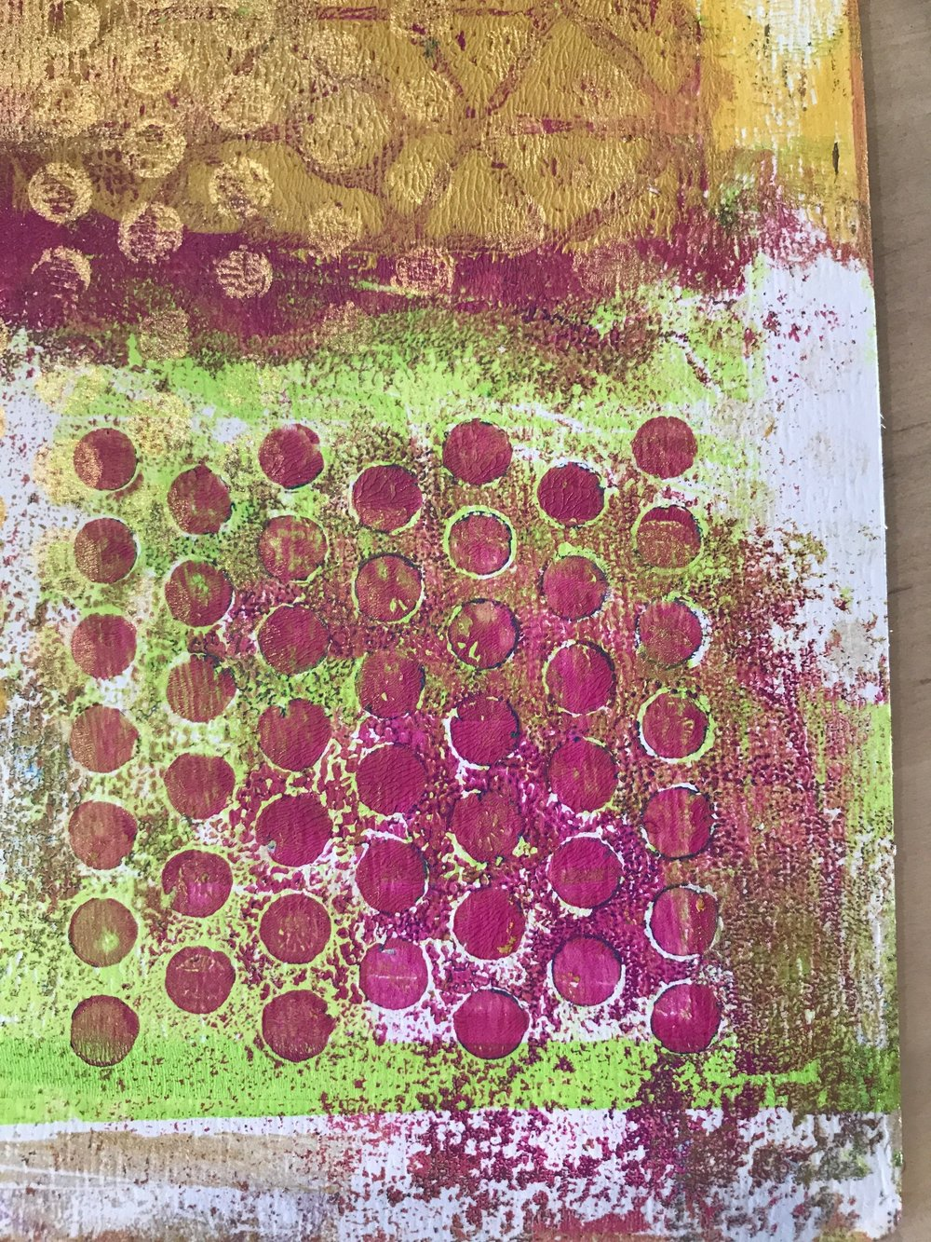
Essential Questions & Understandings/Big Ideas | How can you show texture on paper?  What materials can we use?  What happens when different colors layer on top of others?  How do artists create textures?  what are some ways textures can make you feel
Key Vocabulary | recycle  Printmaking  Composition
STAGE 2: Assessment Evidence ~ What is evidence of Mastery?
Assessment Part 1 | Hands on: students will get to apply what they’ve learned about textures and patterns to make their own designs.  using assigned tables (each table is colored), students at the table will use the color variations according to the name of their table to create 6-8 prints. They will get to experiment with different textures. I am not asking students to write their names on their papers, because next class, I will pass out the variety of colors created to each table, so sharing is involved, and there is minimal conflict.
Possible misconceptions or learning gaps | More is better. Know when to stop. Hold it up and if you like what you see, don’t keep adding.
STAGE 3: Learning Plan ~ What are the strategies and activities you plan to use?
Snapshot / Warm-up | Recap: What did we talk about last class?
Instructional Strategies | Demonstrating techniques  Cooperative learning- paying attention to demo and working together  Divide students into groups- each person in the group will take turns  two or three plates at each table so students in groups can collaborate and take turns  materials:  paint  recycled materials ( bubble wrap, plastic wrap, wire, net, stencils, etc.)  8x11 paper  roller  paper towels  aprons/smock  drying rack  pencil
Teaching and Learning Activities | The teacher will show the students different ways of creating texture  -have an example of the end product  - write name and grade on the back of the paper  -squirt paint onto surface  - roll paint evenly to coat surface  - lay down texture sample ( ex; bubble wrap) and lift it up  -lay paper over the surface and gently rub over the back of the paper  - peel paper up to reveal  -place paper on the drying rack  We learn from our mistakes.  We take turns and help each other.  Students will repeat the steps to me so I know they understand.  Students are encouraged to help each other and wait their turn using different textured materials on the gelli plate.
Differentiation  - Flexible grouping  - Tiered instruction  - Varied products | Higher Level Thinking  Thinking about composition. Does the entire paper need to be covered? Think about colors mixing. Know when you’re finished. | Technology Use  Playing music, when the song changes, students switch. | Connections to other subject areas and/or authentic applications  Applying what they have learned  - making the connection between layers of paint and other object in their lives that might have layers
Checking for Understanding | can texture be shown through layers of paint?  what else has layers?  .
STAGE 4: Closure ~ What did the students master & what are they missing?
Lesson Closure & Student Summarizing of their Learning  Review what students learned or should have learned. Recognize gaps and allow them to help you plan for the next lesson(s). | What did you learn?  How do you feel about this activity?  What did you learn about your art?  How can we take this activity further?  Discuss the next activity, moving forward and branching from this activity
Assessment Part 2 | Exit card- Write 1-3 of your favorite animals or plants. this is to gain a better understanding of their excitement/understand for the lesson.

Teacher Reflection / Effectiveness of Learning

Lesson 3

Teacher: George | Date(s): April 2-4
Grade Level or Course: 2nd | Content or Unit: Layers

STAGE 1: Desired Results ~ What will students be learning?
SOL/Learning Objective  Specify the behaviors, conditions, and criteria. Indicate the verbs used in the Curriculum Framework. | 2.1 The student will generate a variety of solutions to art-making  problems.  2.2 The student will incorporate unanticipated results of art making into works of art.  2.3 The student will depict imaginary experiences in works of art.  2.4 The student will create works of art inspired by a variety of concepts, themes, and literary sources.  Students will use the prints they made from the previous class to cut and repurpose for a collage
Essential Questions & Understandings/Big Ideas | How can layers be used to tell a story?  Look at your paintings/ prints. What do you see? Can the designs and patterns created be used to tell a story or represent something else?
Key Vocabulary  Look for in the Curriculum Framework and other adopted resources. | Eric Carle  Collage  Repurpose  recycle
STAGE 2: Assessment Evidence ~ What is evidence of mastery?
Assessment Part 1  Start with the end in mind! Consider here a sample question or performance task students will need to do as evidence of mastery of this objective. | 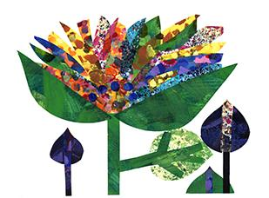credit: Eric Carle museum  Listen to Eric Carle’s, Animals, Animals
Possible misconceptions or learning gaps  Complete the above task yourself; think about what might be hardest for students to grasp? | When creating an image from cut up images, the shape does not have to be exact or fit perfectly like a puzzle. Some shapes will work others than others and colors don’t have to be accurate. (your flower can absolutely have a blue stem and green pedals. Your fish can have four fins or one fin, you choose.)
STAGE 3: Learning Plan ~ What are the strategies and activities you plan to use?
Snapshot / Warm-up | Show other examples of Eric Carle and allow time for questions  This will give them ideas when creating their own collaged animal/plant
Instructional Strategies  Think in term of high yield strategies, such as: | Identify similarities and differences in your paintings and actual animal, plant textures.  Cooperative learning: maybe your classmate has scraps that they aren’t using- share and trade  Steps:  Look at prints and visualize what each texture could be used for  Cut out desired shapes  Arrange before gluing  Glue when ready  Materials:  Prints  Scissors  Paper  Pencil, pens, markers  Glue  Projector
Teaching and Learning Activities | I show them Eric Carle’s examples  I show them what I see in my print.  They discuss what they see in their prints.  We cut out our shapes and arrange them  Students share and work together to create their animal/ plant.
Differentiation  - Tiered instruction  - Varied products  - Personal agendas | Higher Level Thinking  Think about what your designs could look at. Are they circles or could they also be suction cups on an octopus? | Technology Use  Projector and laptop | Connections to other subject areas and/or authentic applications  Things aren’t always as they seem
Checking for Understanding  Check throughout the lesson using: | Think about the materials we used. They were mostly different types of recycled plastic.  Where do you see plastic? (connection: we used plastic to create shapes and patterns for our animals, but in the real world, plastic can be hurtful to these plants and animals)  Group response
STAGE 4: Closure ~ What did the students master & what are they missing?
Lesson Closure & Student Summarizing of their Learning | Connect use of plastic in the class and how else it can be used. Add more words to the vocabulary list.
Assessment Part 2 | Exit card: Where does your animal live?

Teacher Reflection / Effectiveness of Learning

Lesson 4
Teacher: George | Date(s): April 9-11
Grade Level or Course: 2nd | Content or Unit: Layers

STAGE 1: Desired Results ~ What will students be learning?
SOL/Learning Objective | Visual Arts:  2.1 The student will generate a variety of solutions to art-making problems.  2.2 The student will incorporate unanticipated results of art making into works of art.  2.3 The student will depict imaginary experiences in works of art.  2.4 The student will create works of art inspired by a variety of concepts, themes, and literary sources.  2.6 The student will use foreground and background in works of art.  2.7 The student will depict objects according to size and proportion within works of art.  Science:  2.5 The student will investigate and understand that living things are part of a system. Key ideas include  a) plants and animals are interdependent with their living and nonliving surroundings;  b) an animal’s habitat provides all of its basic needs; and  c) habitats change over time due to many influences.
Essential Questions & Understandings/Big Ideas | What similar shapes and patterns do you see in your print hat you also see in an animal?  How can you use the shapes and patterns in front of you to mimic the same texture in animals?
Key Vocabulary  Look for in the Curriculum Framework and other adopted resources. | Background  Composition  Environment  Adaptation  mimic
STAGE 2: Assessment Evidence ~ What is evidence of mastery?
Assessment Part 1  Start with the end in mind! Consider here a sample question or performance task students will need to do as evidence of mastery of this objective. | Where does your animal live?  What are ways it adapts to its environment?  what belongs in their environment?  What is in the background?
Possible misconceptions or learning gaps  Complete the above task yourself; think about what might be hardest for students to grasp? | When creating an image from cut up images, the shape does not have to be exact or fit perfectly like a puzzle. Some shapes will work others than others and colors don’t have to be accurate. (your flower can absolutely have a blue stem and green pedals. Your fish can have four fins or one fin, you choose.)
STAGE 3: Learning Plan ~ What are the strategies and activities you plan to use?
Snapshot / Warm-up  Activate prior knowledge and get students thinking about & motivated for today’s lesson. | project images to refresh their memory of our goal and demo a possible example.  - I hold up a print and explain to students what I see and ask what they see, to give them a better understanding
Instructional Strategies | students will receive random prints of all the variations of colors  write name on the back of white sheet (will be the background of their animal or plant)  observe the patterns and try to find a similar shape and or texture to an animal or plant.  cut out shapes (do not discard excess)  arrange cut-out shapes in desired order  glue them down  students may add to their plant or animal with pen or marker, but the goal is to rely heavily on created patterns in prints.  Materials:  Paper  Scissors  Glue  Markers  White board  Dry erase markers
Teaching and Learning Activities | I talk about my decisions in my own example  We discuss and list possible objects to include in their own  Students begin cutting and pasting and creating their backgrounds.  students can choose to write or share about their plant or animal if there is extra time.
Differentiation  Some ideas include:  - Flexible grouping  - Tiered instruction  - Varied products | Higher Level Thinking  Think about other materials we use everyday are discarded. | Technology Use  projector | Connections to other subject areas and/or authentic applications  Reusing materials like we have done in class can reduce the amount of waste that goes into the ocean and other environments
Checking for Understanding  - Class discussions | Ask for volunteers to show work and give a brief explanation.
STAGE 4: Closure ~ What did the students master & what are they missing?
Lesson Closure & Student Summarizing of their Learning  . | While we may use plastic and recycled material in the classroom to create our plants and animals, it is important that we either reuse our plastics or dispose of them properly so they don’t hurt the plants and animals that we love.
Assessment Part 2 | If there is time:  Classroom art show!  Students will set up their work at their desk and we will walk around and look at each other’s work.

Teacher Reflection / Effectiveness of Learning

