**Creating Gradients**

Tint: adding white to a color

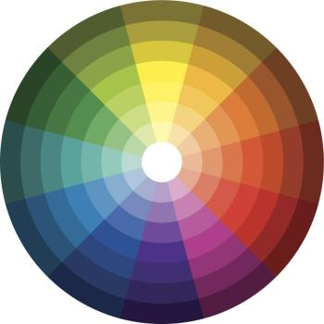

Shade: adding black to a color

|  |
| --- |
|  |
|  |
|  |
|  |
|  |